- Step 1: Python installation and set up
  - Download python from the main website: https://www.python.org/downloads/
  - Click on Python.exe when finished to start installation
  - Choose path for the installation and check environment variable checkbox then skim towards the end to finish downloading
  - In your computer Search Bar, search for environment variable and choose “Edit the system environment variables” to run python command in cmd or VS Code terminal
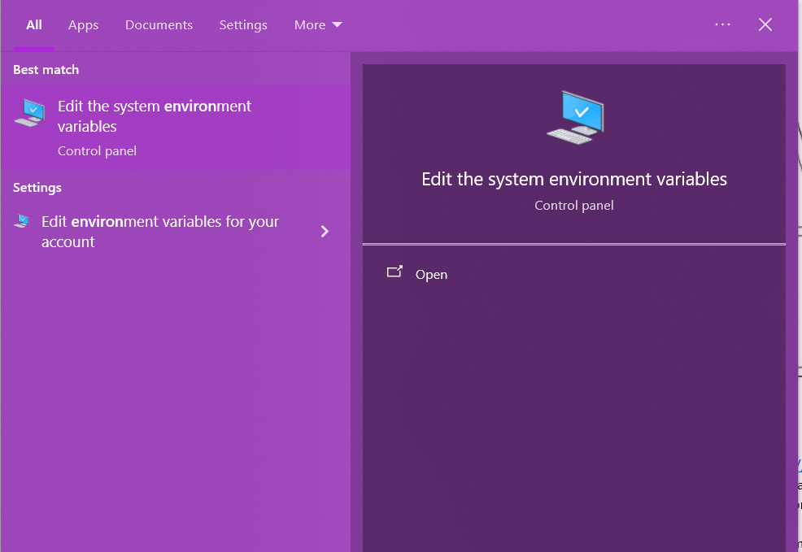
  - Choose environment variables in Advanced tab and choose Path in system variables
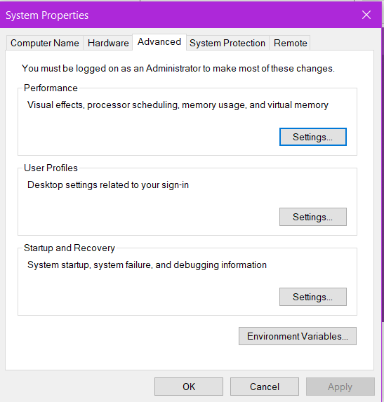 | 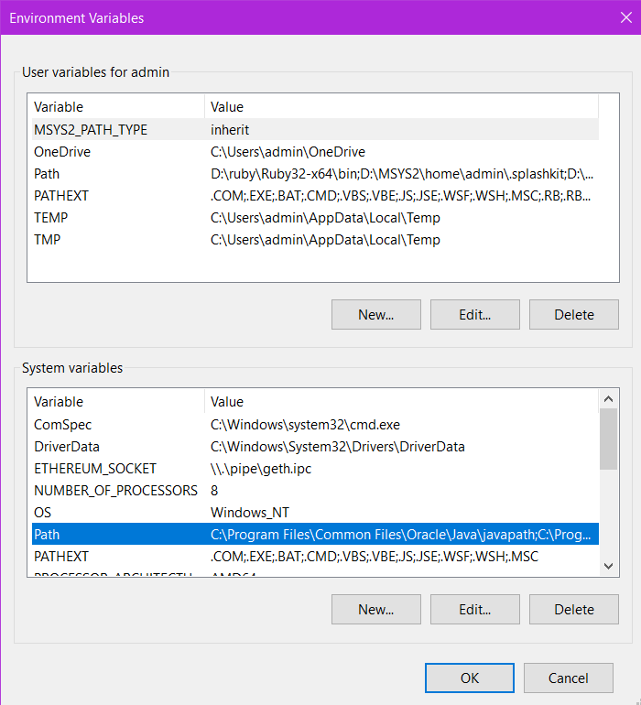

  - Add path for the Scripts folder of the location you install Python (this is to run “pip install” later on)
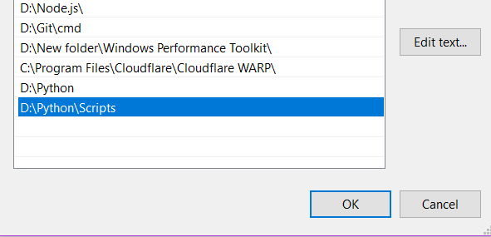
- Step 2: Installing necessary libraries
Within cmd or VS Code terminal, type these commands to install required libraries to run the code:
  - pip install opencv-python
  - pip install torch torchvision torchaudio
  - pip install “numpy<2”
  - pip install scikit-learn
- Step 3: Run the code
After setting everything, run the code using said commands when inside valid terminal
- cd “<project folder>/AVSS2019/src/Demo”
- python demo.py “<video path>” “<ground truth file path>”

